Instructions for Copying and Sharing this Document
📣 DELETE THIS BOX BEFORE SUBMITTING!!

Step 1: Click “File -> Make a Copy” to make a copy of this document that you can edit.
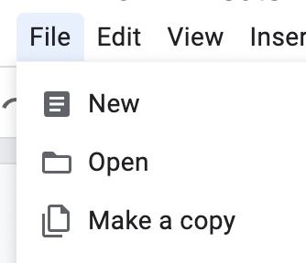
Step 2: Change the Share settings to “Anyone with Link -> Editor”. This will allow our graders to leave comments on your submission.

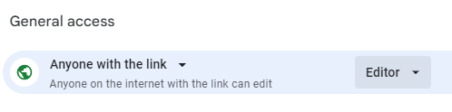

CYB102 Project 1 (🔗 Instructions Page)

👤 Student Name:
✉️ Student Email:

Reflection (Required)
*Feel free to skip these for now and come back after you’ve completed the project!*

🤔 Reflection Question #1: If I had to explain “what are .pcap files” in 3 emojis, they would be…
(Feel free to put other comments about your experience in this unit here, too!)

🧠Reflection Question #2: How does Wireshark help us to analyze network traffic?

📣 Shoutouts: Share appreciation for anyone who helped you out with this project or made your day a little better!

Required Challenges (Required)

Item #1: The malicious actor's IP address:
TODO

Item #2: The subject lines of three different phishing emails:
- TODO
- TODO
- TODO

Item #3: An explanation of how you went about finding the bad apple from just the .pcap files: (Please be specific about what filters/searches you used!)
TODO

Stretch Challenge (Optional)

Item #1: Three screenshots of three different .eml files showing the content of phishing emails you identified:
[Insert Screenshot Here]
[Insert Screenshot Here]
[Insert Screenshot Here]
Notes (Optional):

Submission Checklist
👉Check off each of the features you have completed. You will only be graded on the features you check off.

Required Challenges
- Item #1
- Item #2
- Item #3

Stretch Challenge
- Item #1
💡Tip: You can see specific grading information, including points breakdown, by going to 🔗 the grading page on the course portal.

Submit your work!
Step 1: Click the Share button at the top of your screen double check that anyone with the link can edit.

Step 2: Copy the link to this document.
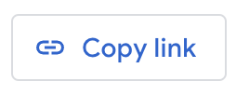

Step 3: Submit the link on the portal.

